# ASSIGNMENT NO-11

* Problem Statement:- **Build Scaling Plans in AWS that balance load on**

**Different EC2 instances.**

* **Steps:-**
* **Template Creation**

1. Go to EC2 dashboard and in the left side select “**Launch Templates”.**



1. Click **New launch template .** Give template name, template version, check auto scaling guidance box.

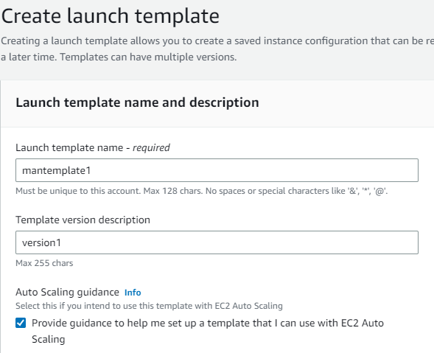

1. In hardware select ubuntu, instance type t2.micro ,give key pair name(in case if you have existing key pair give that otherwise create new one).

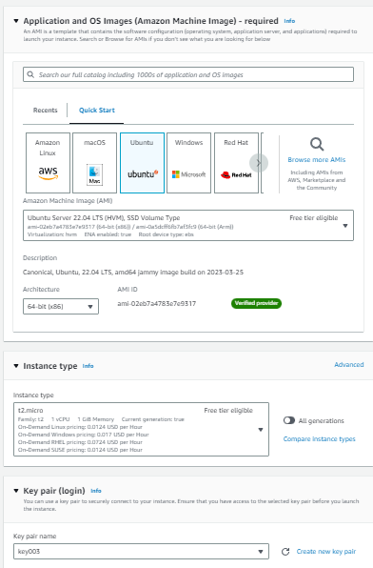

1. In Network settings select existing security group and select the existed security group which is created previously.

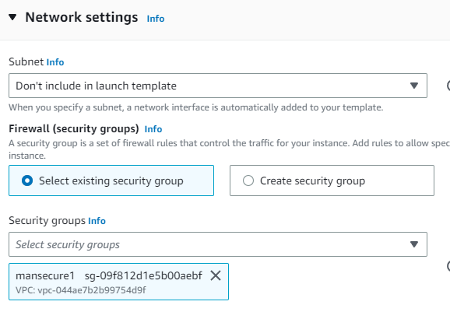

1. In advanced details in user data section type the following commands-

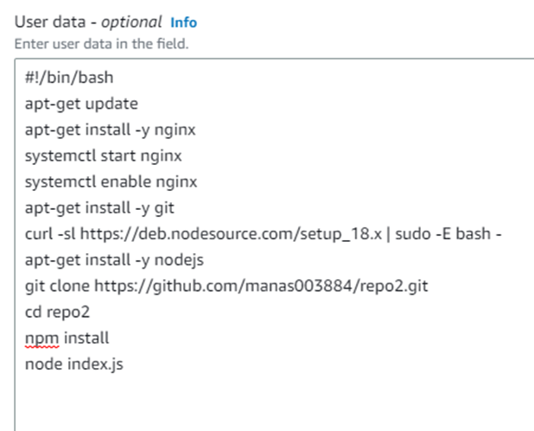

(In git clone line user can give his repo name and cd line the repo name will be according to his repo name.)

Note- before copying the github repo make sure it is public. If not then perform following steps-

1. Go to repo settings and by scrolling down in danger zone click “**change repository visibility”.** And change it to public.

* **Auto Scaling Groups**

1. In EC2 dashboard click Auto Scaling Groups. Click on **Create Auto Scaling group.**

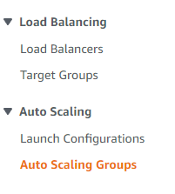

1. Give auto scaling group name (ex-manasautoscale1). In launch template click on the existing template(ex-mantemplate1) ,give version **Latest(1)** and click next

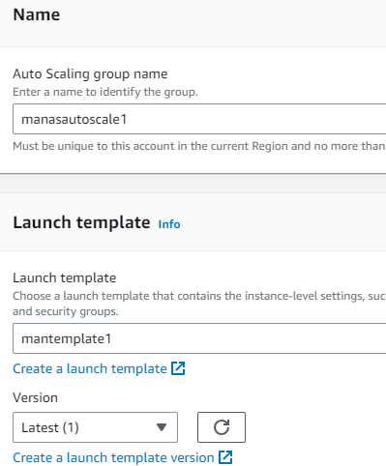

1. In Network ,Availability Zones click all the zones and subnets and click next.

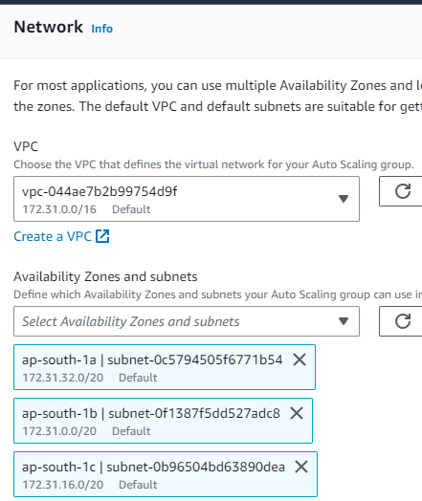

1. in load balancing click “**Attach to a new load balancer**”, in load balancer scheme select “**internet-facing**” , in listeners and routing give port number 4000 and default routing select autoscaling group(ex-manautoscaling1-1|HTTP). And click next.

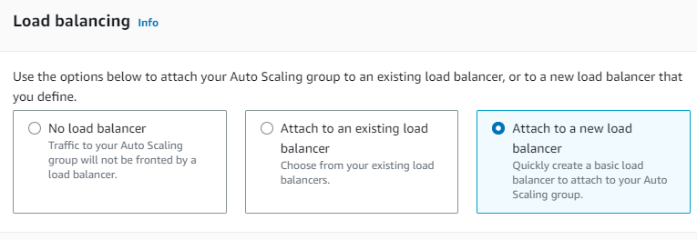



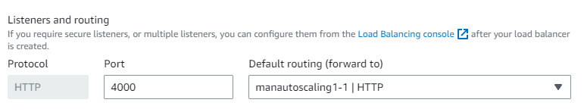

1. **in Group size** give desired capacity 2,minimum capacity 2,maximum capacity 3.

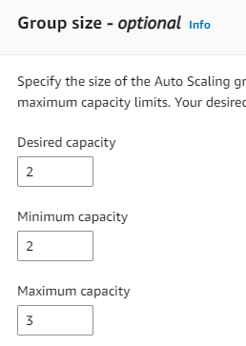

1. **In** Scaling policies click “ Target tracking scaling policy” and instances need section type 300.

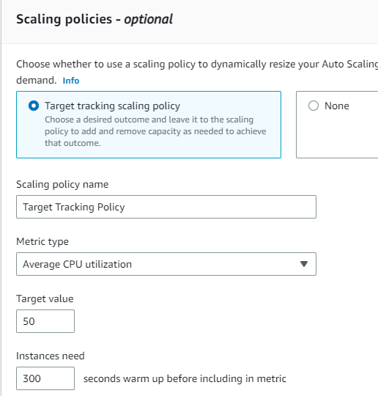

**Click next** and click **Create Auto Scaling group**. And it will be created.

Now, we have to crash these two running servers. for that we will crash one server with bitvise ssh client and in another one we will crash through directly opening terminal.

* + **For one server:**

1. Copy public IPv4 address(ex-65.2.3.43) and paste it on Bitvise SSH Client.

Give username ubuntu, initial method publickey, in client key manager import that same existed key pair .pem file(ex-key003.pem) and click Global1 in Client key.and click log in.

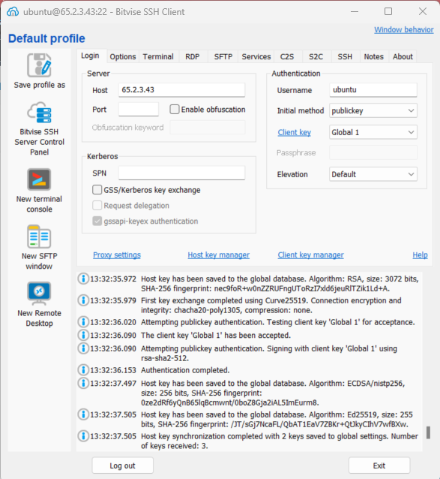

1. In Terminal type **nano infi1.sh** and in the file write the following lines of code and save it.

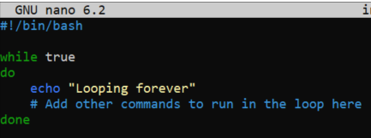

1. To execute the file give command **chmod +x infi1.sh**.
2. To run give command **./infi1.sh** and infinite loop will start.

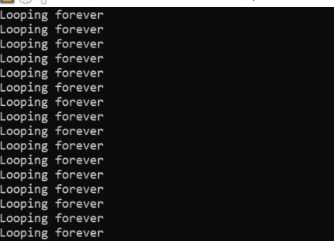

* + **For another server:**

1. Click on connect option and one terminal will open.
2. In the terminal type the command as same as previous. And run .

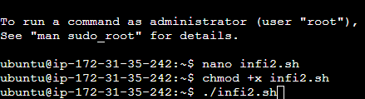

Now, the servers will be overloaded and we can see that by click on CPU utilization.

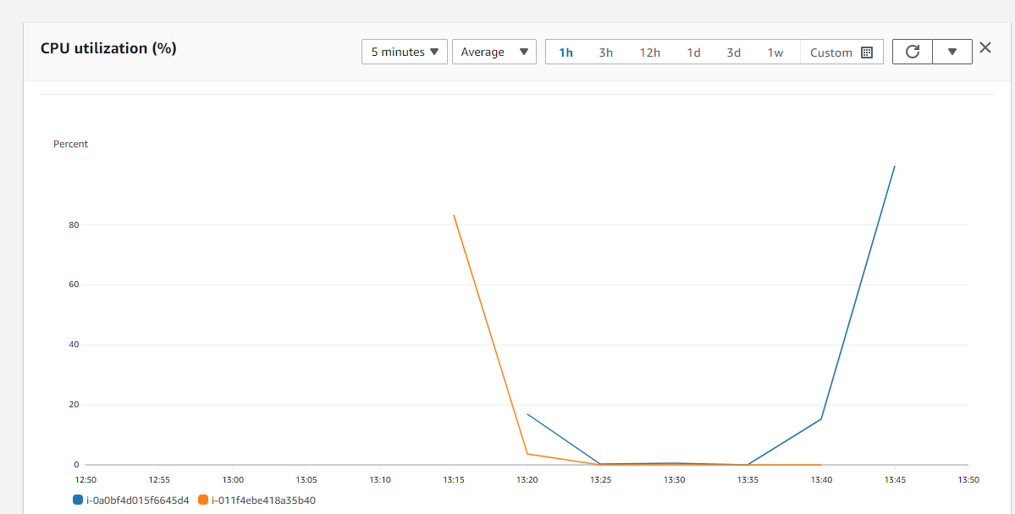

After some time,we can see that new instance is created automatically for load balancing.

